We Shine Study Circle
[_iy – 2018

TNPSC

elg;G epfo;Tfs;

(CURRENT AFFAIRS)

MAY - 29.05.2019

Main Office @

Weshine Study Circle
Chromepet, Chennai
Phone: 8939144344, 8939244344

Branch Office @
Weshine Study Circle

Plot No: 47/60, “AK” Block, 3rd Floor, West Wing, Gokul Arcarde,
7th Main Road, Anna Nagar No.2, Sardar Patel Road, Adyar
Chennai, Tamil Nadu – 600 040. Chennai, Tamil Nadu – 600 020.

https://weshineacademy.com

INDEX

- NATIONAL NEWS
- INTERNATIONAL NEWS
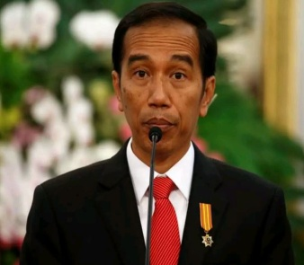
- SCIENCE AND TECHNOLOGY
- SPORTS
- APPOINTMENTS
- IMPORTANT DAYS
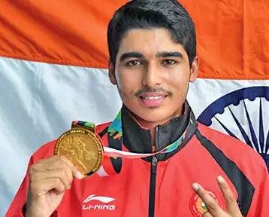

NATIONAL NEWS
- The architectural heritage of Orchha town in Madhya Pradesh added to the Tentative List of UNESCO’s World Heritage Sites. The architectural heritage of Orchha town depicts a unique style of the Bundela dynasty.
  - The Archaeological Survey of India (ASI) had sent a proposal to UNESCO to include the architectural heritage of Orchha town in its list of World Heritage Sites on April 15, 2019.

- International Day for Biological Diversity tree ambulance was inaugurated in Chennai, Tamil Nadu by Vice President of India, Venkaiah Naidu.
  - The ambulance will help in planting trees that have been uprooted, and offer other services such as a seed bank, distribution of plants, and helping citizens in tree plantation drives.

INTERNATIONAL NEWS
- Russia launched the world’s largest nuclear-powered icebreaker ‘Ural’ at the Baltic Shipyard in St Petersburg in order to improve its ability to tap the Arctic’s commercial potential.
  - Russia is preparing for shipping via the Northern Sea Route (NSR).

SCIENCE AND TECHNOLOGY
- The Defence Research Development Organization (DRDO) successfully test-fired the new version of the Akash surface-to-air defence missile system with a new indigenously-developed seeker in Balasore off the Odisha coast on 27 May.

SPORTS
- India’s 17-year-old shooter Saurabh Chaudhary broke his own junior and senior world record to win his second gold medal in 10m Air Pistol event in ISSF Gold Cup 2019.
  - Saurabh won 10m Air Pistol event with 246.3 points, breaking his own senior record of 245 points and junior record of 245.5 points. This is Saurabh’s second gold in the same event.

APPOINTMENTS
- Sikkim Krantikari Morcha (SKM) president Prem Singh Tamang, who is famously known as P.S. Golay, took oath as the Chief Minister of Sikkim on 27th May.
  - Fifty-one-year-old Tamang was administered the oath by Governor Ganga Prasad at Paljor Stadium in Gangtok, Sikkim. He took the oath in Nepali.

IMPORTANT DAYS
- Amnesty International Day is being observed on May 28. It has been observed annually on May 28th since 1962.
  - Amnesty International is a non-governmental organization that focuses on the protection of human rights working to prevent abuses to human rights, to fight for justice for those whose rights have been violated, and to expand and enforce human rights protections in international law.

